The following document provides some general guidelines to reference for fire hydrant placement and configuration within the Monroe Township Fire Department’s first-due district. The Monroe Township Fire Department will review and comment on all fire water service drawings when they are submitted to the responsible Building Department. Comments made by the Fire Department must be addressed regardless of any other approvals granted by the responsible water authority and/or Engineering Department.

Spacing

The Fire Department’s strong preference would be to have hydrants located on approximately 300’ spacing. The IFC (2018) language is as follows (this is the minimum acceptable criteria):

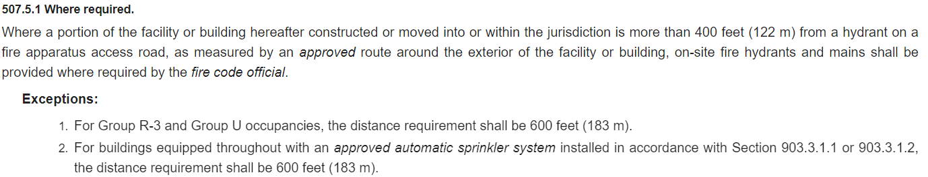

Emphasis should be placed on “measured by an approved route”. A drawing showing hydrants and a simple radius around each hydrant is probably not sufficient unless all areas within that circle are paved and designated as fire apparatus access roads.

Hydrant spacing in the City of Johnstown in certain zoning districts is also addressed by City-specific ordinances. Those minimum requirements are stricter than the minimum requirements found in the IFC.

Location Near Fire Department Connections (FDCs)

Each fire department connection shall be located not more than 100’ from the nearest hydrant as required by NFPA 14 Section 6.4.5.4. The Fire Department’s strong preference would be to have hydrants located no more than 75’ from each FDC. In addition, per IFC section 912.2 “fire department connections shall be so located that fire apparatus and hose connected to supply the system will not obstruct access to the buildings for other fire apparatus”. While the installation and siting of FDCs may not be concurrent with installation of the underground fire mains and fire hydrants, the location of fire hydrants will impact the location of all FDCs.

Model

The municipal water authorities (Columbus and Johnstown) have standards for the public fire hydrants. Once the piping transitions to private property, the Fire Department is not aware of any requirements to use those same hydrants on a private fire service main. That said, this requirement should be verified with the responsible water department as well.

All fire hydrants shall have an integrated 5” Storz fitting on the steamer connection. Beyond that requirement, the Fire Department has no preference on the model or configuration of new hydrants that are installed.

Drains

In Johnstown, all hydrants shall be self-draining. On the Columbus water system, self-draining hydrants are prohibited. The Columbus rule exists due to the high groundwater table in central Ohio. It is not unheard of to find hydrants with drains full of water during wet weather periods… often leading to freeze damage during the winter months.

The Fire Department believes the high groundwater issue affects some sites in New Albany, but we are not aware of any similar issues within the Johnstown city limits. For projects between those two areas, we are unable to speculate whether the new hydrants should be self-draining. If non-draining hydrants are installed, however, the site Owner will hold responsibility for pumping the hydrants dry at least annually prior to the onset of freezing weather conditions.

Color Scheme

On the Columbus water system, a solid color hydrant (red for the potable water system or gray for the Beauty Campus gray water system in New Albany) signifies a hydrant owned/maintained by the municipal water authority. A hydrant with a bonnet painted white signifies a privately owned/maintained hydrant. To date, the City of Johnstown has not adopted similar rules. The Fire Department doesn’t have any strong opinions about the barrel color, but does prefer that all privately owned/maintained hydrants be painted with a white bonnet to maintain consistency with current standards. The Fire Department does not currently require water supply color markings (consistent with NFPA 291).

Isolation Valves

NFPA 24 (2016 edition, section 6.6.1) requires sectionalizing valves on private fire service mains "such that the number of fire protection connections between sectional valves does not exceed 6." The Fire Department considers “connections” to include branch lines to individual fire hydrants as well as branch lines feeding fire risers internal to a building. It is important to recognize that the number and location of hydrants can impact the need for additional sectionalizing valves.

